GYO 2021 CIRCLES OF SUPPORT
Including Donations Received between October 1, 2020 and October 23, 2021.
Gifford Florida Youth Orchestra’s 2020/21 Circles of Financial Support
Honoring African American Musicians and GYO Donors

Aaron Dworkin Circle: Gifts up to $49.99
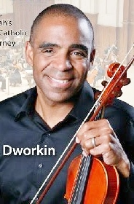
Dr. Aaron Dworkin is an accomplished acoustic and electric violinist, and a spoken-word and visual artist. Born in New York, his biological father was of Irish descent and his biological mother was African American, while his adoptive family was Jewish. His adoptive mother, an amateur violinist, sparked his early interest in music. He is the Founder and President of The Sphinx Organization, the national arts organization that transforms lives through the power of diversity and the arts. Dr. Dworkin was President Obama’s first appointment to the National Council on the Arts.
Circle of Supporters:
Alma Sansha Grin, Amazon Smile, Amber Allenbaugh, Andrea Shearer, Christine Steinkrauss, Ebrahim Siadat Melodika Nafe, Elizabeth Stanley, Fae Kopacka, Gaye Tolan Hatfield, Gerald & Patrica Lussie, Janice Allen, Jill Thompson, Juneva Walters, Just Bonique, Just Give-Great Non Profits, Katherine E. Washington, Linda Embry, Linda Kloss, Linda McNeal, Lisa Page, Margaret Sims, Margie Zunk, Myrta B. Boyle, Patricia Warner, Phyllis J. Permar, PJ Brown, Pangea The Artist, Robert & Evangeline Y. Houlihan, Sherri D’Allessio, Stephen & Martha Smith, The Boyle Living Trust, Wendy Palmer,

Regina Carter Circle: Gifts between $50 and $99.99
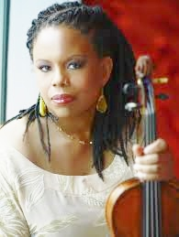
A classically trained jazz violinist who began studying the violin in her hometown of Detroit at age four. Known as the most significant jazz violinist since Jean-Luc Ponty of the late '60s. As a teenager, Regina took master violin classes from Itzhak Perlman and Yehudi Menuhin. As a gesture of solidarity for America, after the September 11th attacks, the city of Genoa, Italy invited her to perform on Niccolo Paganni’s Il Cannone Guarnerius, a 1743 violin. She became the first jazz musician to play this priceless instrument.
Circle Supporters:
Akosua Hobart, Alfred & Kathleen Whittet, Anne Christy Speirn Smith, Armagene Perry, Brown, Phyllis, Candi Sary, Cynthia Jorgensen, Dale and Arely Gonering, David & Joyce Thompson, Edwin S. & Carol W. Mullett, Freddie & Faye Woolfork, Gerald & Ann Reynolds Parks, Godfrey & Betty Gipson, Joe Idlette III, John Meikle Realty, LLC, Joseph Bauer, Joyce Bol, Joyce Gibrick, Judi C. Miller, Kathleen Connolly, Kellitia Marshall, Larry Staley, Laura Shucart, Nancy Stiefel, Oblates of St Frances Desales, Oscar Sales, Pamela O'Donnell, Patricia Gibbons, Powell-Perry, Iva, Rainbow Johnson, Richard Atkinson, Robert Lee Temple, Ronald & Susan Match, Sunshine Rehabilitation Center, Terkedria Phillips, Thomas Helfrich, Thomas W. & Cheryl A. Mackie, Vida Plena Herramientas de Vida & Organizacion

Beethoven Circle: Gifts between $100 and $249.99
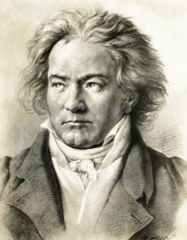
German born Ludwig Van Beethoven is considered Europe’s greatest classical music composer. His ancestors were Moors (Black people), North African Muslims who conquered parts of Europe and made Spain their capital for over 800 years. One of Beethoven's homes in Vienna, Austria, the music capitol of Europe at the time, was called "the Schwarzspanierhaus," the "House of the Black Spaniard." Beethoven was one of the most innovative and amazing musical geniuses, ever. His deafness made that genius even more so. His music reveals a cultural connection to his African ancestry. He was the first composer to invigorate European classical music with an inherently African rhythmic trait.
Circle Supporters: on the next page …
(Beethoven Circle of Support – continued)

Ahman, Alliance Title of the Treasure Coast, Angela Garcia, Angelia Perry, Barbara Kilgore, Barbara Ruddy, Beatrice Stoner, C. Malle, Carl Word, Carol Malle, Catherine Katrovitz, Celucien & Katia Joseph, Cesar Perez & Martha Gonzalez, Christopher Dunn, Coleman's, Daniel & Laurie Fourmont, David Hedges Ins Agency, Debbie Avery, Debbie Sindall, Dhumavati Jaya, Donald Holt, Dr. Leon Geary, Elizabeth Lapham, Elwood Holzworth, Empresa LLC, First Woman's Church in the City of the Angels, George Blythe, Happy Dollars, Healing Head to Toe, Jane Bialosky, Janet Mathram, Jeannie Hobert, Joan Woodhouse, John Fortier, Joseph & Rosemary Flescher, Juan Hernandez, Kenneth Arendt, Laura Moss, Leona Compton, Leslie Phelps, Linda H. Erbacher, Linda Scott, Lucy Home, Madeline & James Henderson, Marian Wenzel, Mark P. Wygonik, Mary Keaney, Michael & Shawnie Anderson, Ocean Mortgage Capital, Inc., Olive Detering, Opal Nelson, Paul and Carol Amaru, PayPal Giving Fund, Raymond & Ann Marie Rossi, Richard & Sharon Kolor, Richard Swanson, Robert Terry, Ronald & Jackye Hudson, Russell W. & Avery M. Twiss, Salty Dog Marine Center, Inc., Sean Sexton, Sharon Kolor, Sherry G. & John M. Panker, Spiro Vrusho, Susan Holloran, Susan Mirza, The Blackbaud Giving Fund, The Mary Tomlinson Trust, Tiffany Abraham, Van DeVoorde Hall Law, Vera Veruzka, Vero Acupuncture, Wilfred & Dorothy Ann Hart

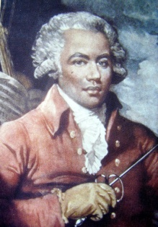
Joseph Bolonge, Le Chevalier de Saint-Georges Circle: Gifts between $250 and $499.00
Bolonge, born on a small West Indian Island, the only child of a black slave and her white master, became one of the most accomplished men in 18th century Europe. He is remembered as the first classical composer of African ancestry. Bolonge was a virtuoso violinist and conductor of the Paris Symphony Orchestra. Known as the "Black Mozart," he was the first musician of color to play for royalty. Before launching his career in classical music, he won fame as one of the best fencers in Europe. He also served as Colonel of the Legion Saint-Georges, the first all-black European regiment during the French Revolution.

Le Chevalier de Saint-Georges Circle of Supporters:

Amy A. Maddalozzo, Antonio & Angela Garcia, Bahais of Indian River County, Brad Touchette, Bryan M Wells/Florida Spine, BSI Environmental Inc., Carole Roberts, Carolyn Butler Norton Esquire, Carolyn Norton, David Driver, Dewey Rogers, Edward Shanaphy, FrenchCozy, Gerald Osterberg & Rosalie Rafter, Gladys Williams, Heller Family Trust, Iva Powell donor, James & Barbara Dimarzo, John and Charlotte Klein, Kenneth Howard Heller, Law Offices of Marcus Rogers, PA,Leslie & Susan Bromwell, Linda Vincent, Martha Gonzalez, Melodika Nafe, Riverside Theater, Susan B Hughes, Susan Hale, Tess Whelan, Theresa Domino, Three Bulls LLC

William Grant Still Circle: Gifts between $500 and $999.99

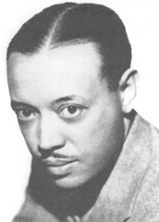
Still began violin lessons when he was 15. Composed music at 16. He heard his Grandmother’s plantation stories and included her spirituals in his compositions. Still was the first African American to conduct a major symphony orchestra in the U.S, directing the Los Angeles Philharmonic in his compositions at the Hollywood Bowl in 1936. In 1955 he became the first African American to conduct a major symphony orchestra in the Deep South, the New Orleans Philharmonic at Southern University. His opera "Troubled Island" was the first African American opera to be produced by a major U.S. company. It was performed at the City Center of Music and Drama in New York City in 1949 and televised over a national network. He wrote over 150 compositions including operas, ballets, symphonies, chamber works, and arrangements of folk themes, especially Negro spirituals, plus choral and solo vocal works.

Circle of Supporters: on the next page

William Grant Still Circle (continued)
Aracely Ramirez-Aguilar, C&C Schneider, Carole & Lawrence Strauss, Carter Hopkins, Deborah Padnuk, Eddie Hudson, Elaine Armour-Word, Elizabeth Allenbaugh, Elizabeth Caldwell, Ellen Lagerquist, Fred & Susan Burt, John Groendyke, L. Frank B. Blaisdell Family Charitable Fund, Marcus Rogers, Marie Sinco, Maryam Siadat, Nelson & Penny Rohrbach Jr., Richard and Barbara Carlin, Rotary Club of Sebastian, Schlitt Insurance Services Inc, Schwab Charitable, Skye White Maher, Susan & Fred Burt, Vanguard Charitable, Violante Fioravanti, William Spillane, Woodruff F. Sutton & Jennifer P. Sutton.
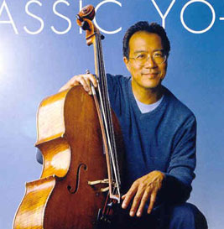
Yo-Yo Ma Circle: Gifts between $1,000 and $2499.99
Born in Paris, Chinese virtuoso cellist Yo-Yo Ma, a child prodigy, began performing at age five. He performed for President John F. Kennedy at age seven, studied at the Juilliard School and Harvard University. He established the ‘Silk Road Project’ to promote the study of the cultural, artistic and intellectual traditions along the ancient Silk Road trade route. He plays a 1733 Montagnana cello nicknamed "Petunia". Yo-Yo Ma's 75 music albums have earned 15 Grammy awards.

Circle of Supporters:
Alex G. Nason Foundation Inc., Ann Hamner, Barkett Family Foundation, Cash, Charles A Brown, Community Church of Vero Beach, Henry Kalt, James Parks, Jean and Gene Cravens Charitable Funds, Lisa Del Brocco, Nelson & Gretchen Cover, Network For Good, Professional Advisory Services, Inc., Robert Webber, Sandy Koufax, Stanley Winters, Warren Obluck

Nokuthula Ngwenyama Circle: Gifts between $2,500 and $4,999.99
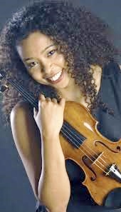
President of the American Viola Society, Ms. Ngwenyama is a solo violist, recitalist, and chamber musician of Zimbabwean and Japanese descent. Born in California, she came to international attention when she won the Primrose International Viola Competition and the Young Concert Artists International Auditions at age 17. She received the prestigious Avery Fisher Career Grant in 1998. As a Fulbright Scholar she attended the Conservatoire National Superieur de Musique de Paris and received a Master of Theological Studies degree from Harvard University.
Circle of Supporters:
Barbara Beckman, Carol Ludwig, Deming Holleran, Indian River Community Foundation – 3H Head, Heart and Hands, Roger & Maria Sobkowiak, Unitarian Universalist Fellowship of Vero Beach Inc., Winslow Tuttle

Duke Ellington Circle: Gifts between $5,000 and $9,999.00

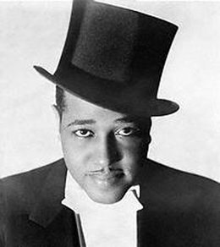
Edward Kennedy "Duke" Ellington was a self-educated American composer, pianist, and jazz orchestra bandleader who gained international recognition through his orchestra's appearances at the famous Cotton Club in New York. Ellington composed thousands of celebrated scores over his 50-year career -- work that has stood the test of time. Pioneering the big band classical jazz world, many of his compositions included elegant parts for violin and viola such as ‘Duke Ellington's Jazz Violin Session,’ an album his band recorded in 1963. A musical giant among giants, Ellington is generally considered to have elevated jazz to an art form equal to other traditional music genres.
Circle of Supporters: New Vision Eye Center, The Mockingbird Foundation, Vero Beach Sunrise Rotary Club.

Frederick Douglas’s Circle: Gifts $10,000.00 and above

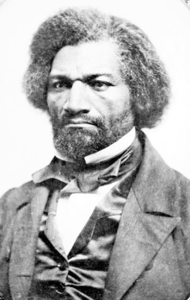
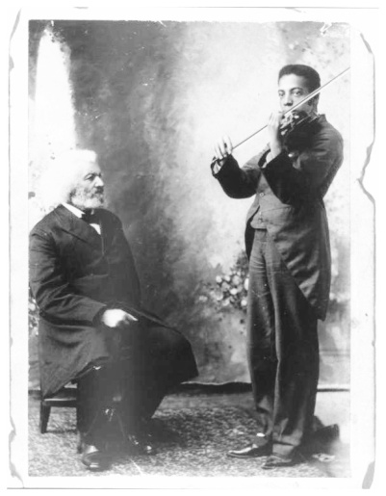
Grand Harbor Born in Grand Harbor, Maryland as a slave in 1818, he taught himself to read and write, escaped to New England, became a preacher, newspaper publisher, bank president, diplomat, musician, fiery orator, and author of hundreds of books and speeches. He spoke seven languages, was an advisor to President Abraham Lincoln, and served as the American Minister to Haiti. His greatest achievements were in the political arena as an eloquent advocate of abolition, women’s rights, and racial justice. Called "The Father of the Civil Rights Movement," his life is memorialized at his home in Cedar Hills in Washington, D.C., where the rooms are filled with mementos of Douglass’ extraordinary life, including his beloved Stradivarius!
Photo: Frederick Douglass teaching his grandson, Joseph Douglass, who became a world-class violinist, performing for many presidents at the White House. A symbol of what we hope our students will do, as well — pass the violin down through their generations.

Circle of Supporters: Corneila T. Bailey Foundation, Dean Neiman, IRC Board of Commissioners, Johns Island Community Service League, Quail Valley Charities Inc., Ruth Campbell Foundation (Web Walker’s Spirit).
When you decide to join our Circle of Support,
Please make your check payable to
The Gifford Youth Orchestra, P. O. Box 691166, Vero Beach FL, 32969 …
and write the name of your chosen musical exemplar in the memo line.
We thank you in Advance for your Sustaining Support!
For more information, Dr. Crystal Bujol 772-213-3007 GYOrchestra@gyotigers.org

Total: $255,050.39

Financial Report
What is covered by tuition?
Logos: CSAC, 3H, Community Foundation, Quail, Johns Island, Sunrise Rotoary, UUFVB,

